**Problem Statement 2: - Mandatory**

Try to understand the dataset of Social_Network_Ads.csv and try to find the best suitable ML algorithm and write the code in python for algorithm from scratch and try to achieve the below output plot.

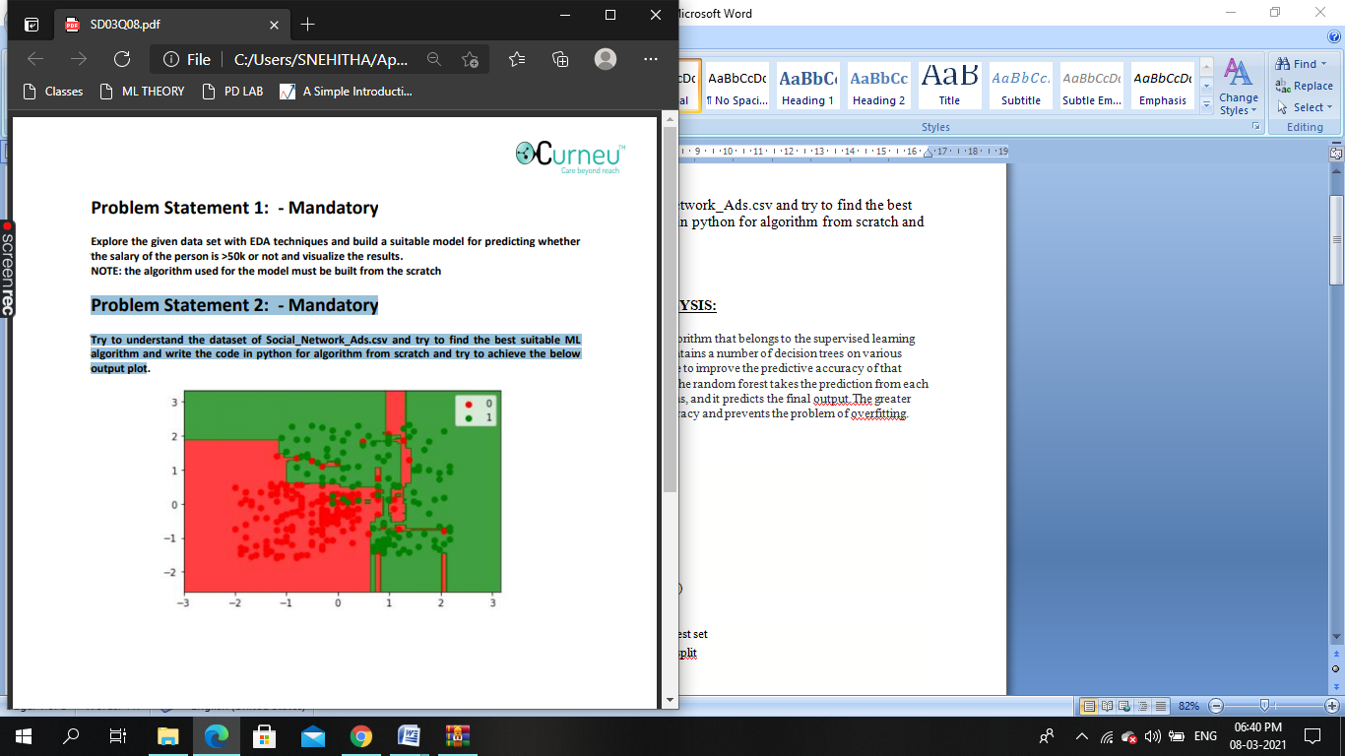

**PROBLEM STATEMENT AND ANALYSIS:**

Random Forest is a popular machine learning algorithm that belongs to the supervised learning technique. "Random Forest is a classifier that contains a number of decision trees on various subsets of the given dataset and takes the average to improve the predictive accuracy of that dataset." Instead of relying on one decision tree, the random forest takes the prediction from each tree and based on the majority votes of predictions, and it predicts the final output.The greater number of trees in the forest leads to higher accuracy and prevents the problem of overfitting.

**CODE:**

# Importing the libraries

import numpy as np

import matplotlib.pyplot as plt

import pandas as pd

# Importing the dataset

dataset = pd.read_csv('Social_Network_Ads.csv')

# Splitting the dataset into the Training set and Test set

from sklearn.model_selection import train_test_split

X = dataset.iloc[:, [2, 3]].values

y = dataset.iloc[:, 4].values

X_train, X_test, y_train, y_test = train_test_split(X, y, test_size = 0.25, random_state = 0)

# Feature Scaling

from sklearn.preprocessing import StandardScaler

sc = StandardScaler()

X_train = sc.fit_transform(X_train)

X_test = sc.transform(X_test)

# Fitting Random Forest Classification to the Training set

from sklearn.ensemble import RandomForestClassifier

classifier = RandomForestClassifier(n_estimators = 10, criterion = 'entropy', random_state = 0)

classifier.fit(X_train, y_train)

# Predicting the Test set results

y_pred = classifier.predict(X_test)

# Making the Confusion Matrix

from sklearn.metrics import confusion_matrix

cm = confusion_matrix(y_test, y_pred)

# Visualising the Training set results

from matplotlib.colors import ListedColormap

X_set, y_set = X_train, y_train

X1, X2 = np.meshgrid(np.arange(start = X_set[:, 0].min() - 1, stop = X_set[:, 0].max() + 1, step = 0.01),

                     np.arange(start = X_set[:, 1].min() - 1, stop = X_set[:, 1].max() + 1, step = 0.01))

plt.contourf(X1, X2, classifier.predict(np.array([X1.ravel(), X2.ravel()]).T).reshape(X1.shape),

             alpha = 0.75, cmap = ListedColormap(('red', 'green')))

plt.xlim(X1.min(), X1.max())

plt.ylim(X2.min(), X2.max())

for i, j in enumerate(np.unique(y_set)):

    plt.scatter(X_set[y_set == j, 0], X_set[y_set == j, 1],

                c = ListedColormap(('red', 'green'))(i), label = j)

plt.title('Random Forest Classification (Training set)')

plt.xlabel('Age')

plt.ylabel('Estimated Salary')

plt.legend()

plt.show()

# Visualising the Test set results

from matplotlib.colors import ListedColormap

X_set, y_set = X_test, y_test

X1, X2 = np.meshgrid(np.arange(start = X_set[:, 0].min() - 1, stop = X_set[:, 0].max() + 1, step = 0.01),

                     np.arange(start = X_set[:, 1].min() - 1, stop = X_set[:, 1].max() + 1, step = 0.01))

plt.contourf(X1, X2, classifier.predict(np.array([X1.ravel(), X2.ravel()]).T).reshape(X1.shape),

             alpha = 0.75, cmap = ListedColormap(('red', 'green')))

plt.xlim(X1.min(), X1.max())

plt.ylim(X2.min(), X2.max())

for i, j in enumerate(np.unique(y_set)):

    plt.scatter(X_set[y_set == j, 0], X_set[y_set == j, 1],

                c = ListedColormap(('red', 'green'))(i), label = j)

plt.title('Random Forest Classification (Test set)')

plt.xlabel('Age')

plt.ylabel('Estimated Salary')

plt.legend()

plt.show()

**OUTPUT:**

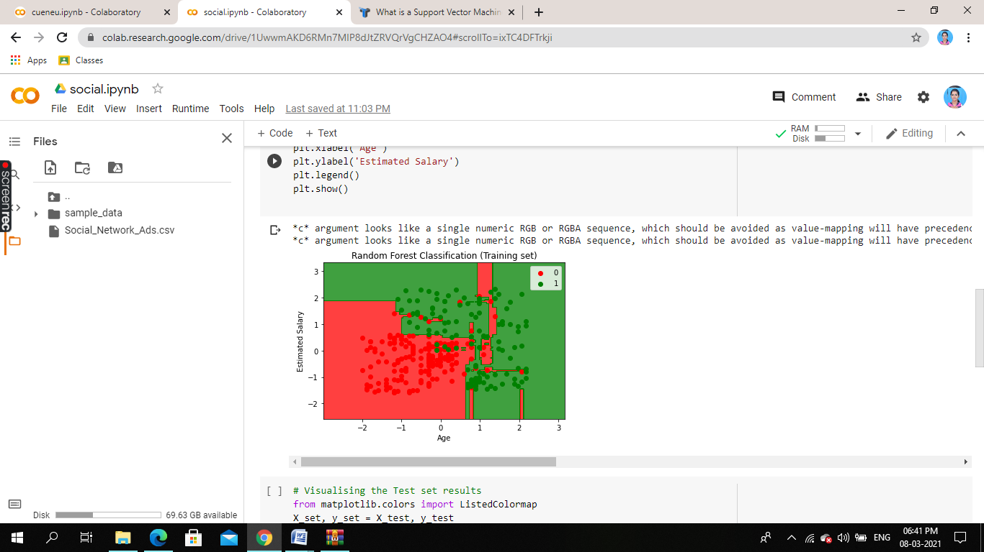

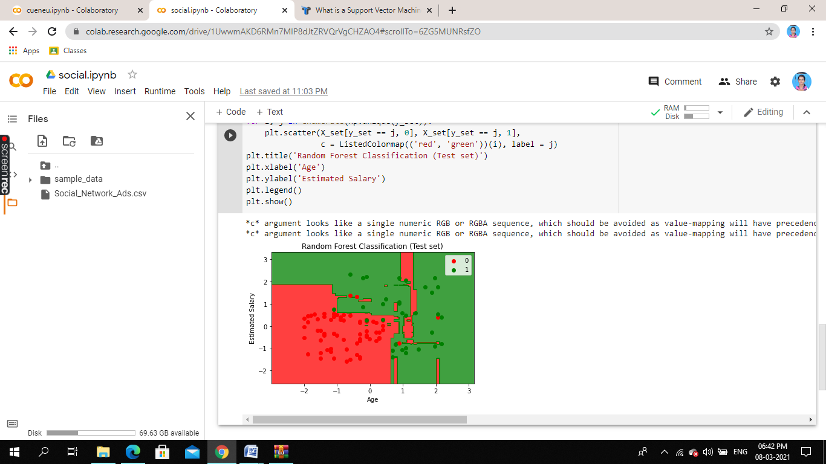

**Conclusion:**

Hence the graph obtained by random forest is similar to the graph given in the question.